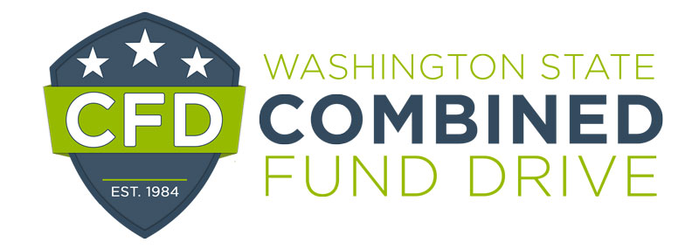

2022 Exemplary Leadership Award Nomination Form

The Exemplary Leadership Award is presented annually to the director, manager or supervisor who provides outstanding support of the Combined Fund Drive and the efforts of campaign leaders and/or coordinators within their agency.

Please complete the following form. The information you provide will be used to determine award winners and may be highlighted at the annual recognition event. Please be clear and as detailed as possible. The form will expand as you type.

Nominee:

Email and telephone number:

Agency:

Supervisor’s name, email, and telephone number:

Your name and title:

Your telephone and email address:

- How did the leader generate enthusiasm and motivate others to support nonprofits through the CFD?

- Did the leader share any goals for the campaign? If so, what were the goals? Were the goals reached? If so, how were they achieved?

- Was an invitation extended to all employees to participate in the campaign and how was the invitation extended?

- Share whether the leader was visible at campaign events and in what capacity.

- What do you feel are the most outstanding characteristics of this individual’s campaign efforts?

- How did the leader recognize volunteers and staff for supporting the campaign?

Please return this form by email to uwcfd@uw.edu by January 6, 2023.

