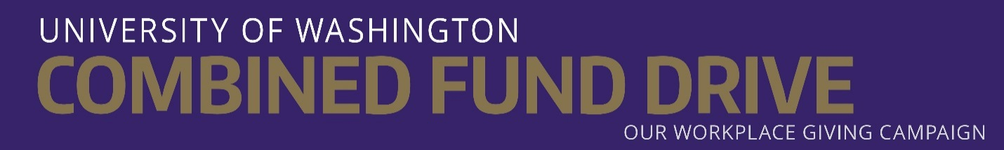

Dear Future DRS Plan Retiree,

Congratulations on your upcoming retirement from the University of Washington. Did you know that, as a DRS plan retiree, you can give to your favorite nonprofits through the UW Combined Fund Drive? You can choose from more than 5,000 charities ranging from the arts, literacy, and medical research to disaster relief, animal welfare and education, including UW programs.
It’s easy to participate.
You can give via personal check, made payable to CFD, and be part of the UW Combined Fund Drive. To make a gift, visit uw.edu/uwcfd to search for Combined Fund Drive member charities. Complete the retiree giving form on reverse and mail it, along with your personal check, to UWCFD, Box 359200.
Consider joining the UWCFD Giving Circle program.
You can become a member of the Giving Circle program and join the many UW donors who give leadership level gifts through the UW Combined Fund Drive when you give via personal check. You will receive special recognition from our UW President and a philanthropist gift in recognition of your generosity and support.
- Gold Philanthropist – $1,200+ per year
- Silver Philanthropist – $600-$1,199 per year
- Bronze Philanthropist – $300-$599 per year
Beginning Oct. 1, 2017, if you are currently giving via payroll deduction, your pledges will automatically continue through your pension upon your retirement as part of the state Combined Fund Drive campaign. You can add, modify or cancel your pledges any time before or after you retire using the form on the reverse or by contacting uwcfd@uw.edu.
Are you a first time donor who would like to set up automatic deductions through your pension? Simply contact the state CFD office at cfd@sos.wa.gov for assistance.
As a retiree, you can change lives and make our world a better place to live. Your gift strengthens communities, supports families, empowers students and protects the environment. Thank you for making a world of difference.
Regards,
UW Combined Fund Drive staff

